MLA03 REINFORCEMENT LEARNING
Software Required: Python IDLE
Library Required: GYM
UNIT-I
1. An autonomous cleaning robot navigates a 5x5 grid where certain cells contain dirt (reward:+1) and obstacles (penalty: -1). The robot starts at the top-left corner and must find an optimal policy to clean the entire grid efficiently. Implement the grid environment as an MDP and write a Python program to simulate the robot’s navigation using different policies.
AIM:
To model a 5×5 grid-based cleaning robot environment as a Markov Decision Process (MDP) and to simulate the robot’s navigation using different policies, including a random policy and an optimal policy obtained using Value Iteration, in order to clean dirt cells efficiently while avoiding obstacles.

ALGORITHM (Value Iteration based Navigation):
- Define the grid environment with rewards for dirt and obstacles.
- Initialize the value function for all grid states to zero.
- For each state, evaluate all possible actions.
- Update the value function using the Bellman optimality equation.
- Repeat the value update until convergence.
- Extract the optimal policy from the converged value function.
- Simulate robot navigation using:
  - Random policy
  - Optimal policy
- Compare the paths followed by each policy.

PSEUDOCODE:
Initialize grid size = 5×5
Define dirt cells with reward +1
Define obstacle cells with reward −1
Define actions = {UP, DOWN, LEFT, RIGHT}
Set discount factor γ = 0.9
For each state s in grid:
V(s) ← 0
Repeat until convergence:
For each state s:
V(s) ← max over actions a of
[ R(s,a) + γ × V(s') ]
For each state s:
π(s) ← argmax over actions a of
[ R(s,a) + γ × V(s') ]
Initialize robot start position at (0,0)
For each time step:
Select action using policy π
Move to next state
Accumulate rewards
Stop when all dirt cells are cleaned

REFERENCE LINK:
- Sutton & Barto – Reinforcement Learning: An Introduction
https://www.andrew.cmu.edu/course/10-703/textbook/BartoSutton.pdf
- Gridworld MDP explanation
https://towardsdatascience.com/gridworld-and-markov-decision-process-mdp-8c5b1b47a0e6

OUTPUT:
Random Policy Output
Robot Path:
(0,0) → (0,1) → (1,1) → (1,0) → (2,0) → (1,0) → (1,1) → (2,1)
Total Reward: Low
Steps Taken: High
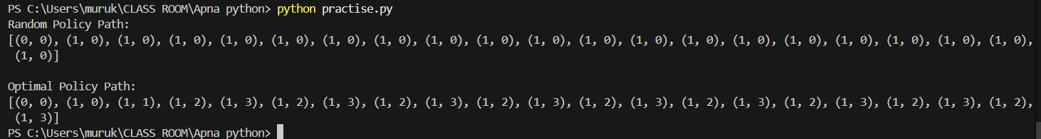
Optimal Policy (Value Iteration) Output
Robot Path:
(0,0) → (0,1) → (1,1) → (1,2) → (2,2) → (3,2) → (3,3)
Total Reward: High
Steps Taken: Minimum

RESULT:
The optimal policy obtained using Value Iteration enables the robot to clean dirt cells in fewer steps and with higher cumulative reward compared to a random policy. This demonstrates that modeling the environment as an MDP and applying dynamic programming techniques results in efficient autonomous navigation.

09. A call center wants to optimize the assignment of customer service representatives to incoming calls. Implement a Monte Carlo simulation to estimate the value function for different assignment policies in Python.
AIM:
To implement a Monte Carlo simulation for estimating the value function of different call assignment policies in a call center, in order to evaluate and compare their long-term performance.
ALGORITHM (Monte Carlo Policy Evaluation):
- Initialize value function V(s) arbitrarily.
- Initialize returns list for each state.
- For each episode:
  - Generate an episode using the given policy.
  - For each state visited:
    - Compute total return G from that state.
    - Update average return for that state.
- Repeat for many episodes.
- Compare value functions for different policies.

PSEUDOCODE:
Initialize V(s) for all states
Initialize Returns(s) = empty list
For each episode:
Initialize empty episode list
Reset environment
While episode not ended:
Observe state s
Choose action using policy π
Execute action, observe reward r
Store (s, r) in episode
G = 0
For each state s in episode (from last to first):
G = γ * G + r
Append G to Returns(s)
V(s) = average(Returns(s))

SAMPLE OUTPUT:
Value Function (Random Policy):
{0: 3.12, 1: 2.45, 2: 1.01, 3: -0.76}
Value Function (Greedy Policy):
{0: 3.89, 1: 3.01, 2: 1.98, 3: -1.10}
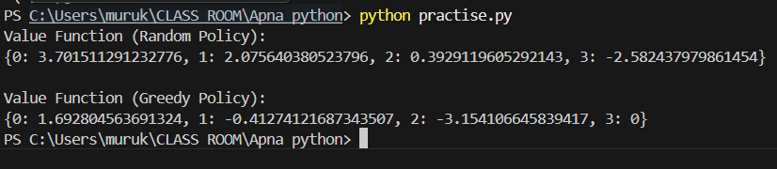

RESULT:
The Monte Carlo simulation estimates the value function for different call assignment policies. The greedy policy achieves higher expected returns in states with fewer busy representatives, indicating better call handling efficiency compared to a random policy.

